ASSIGNMENT 1
- Explain the difference between frontend, backend, and full-stack development with suitable real-world examples.
Ans:- • Frontend Development: Refers to the client side of web development. It focuses on everything the user sees, touches, and interacts with directly in their browser (UI/UX layout, buttons, forms, animations).
- Tools/Languages: HTML, CSS, JavaScript, React, Vue, Angular.
- Real-World Example: The user interface of Netflix, where you scroll through movie posters, play trailers, and click buttons.
• Backend Development: Refers to the server side of web development. It handles core application logic, database management, user authentication, security, and server configuration.
- Tools/Languages: Node.js, Python (Django/Flask), Java, PostgreSQL, MongoDB.
- Real-World Example: The processing backend of Netflix that verifies your subscription, fetches your watch history from the database, and streams the correct video file to your browser.
• Full-Stack Development: Involves working on both the frontend and backend layers of an application. A full-stack developer is capable of building an entire web application end-to-end, from user interface design to database schema management.
- Real-World Example: Building an entire e-commerce store (like Amazon) — designing the product listing page (Frontend) as well as writing the payment processing and inventory update API endpoints (Backend).

- Create a simple diagram showing how the client-server model works in web architecture.
Ans:- [ Client / Browser ] --- (1) HTTP Request ---> [ Web Server ]
<-- (2) HTTP Response ---
- Describe how a browser requests and displays a web page from a web server.
Ans:- • DNS Lookup: Resolves the URL domain name to an IP address.
• HTTP Request: Sends a request to the target server for page files.
• Server Response: The server sends back HTML, CSS, JavaScript, and assets.
• Rendering: The browser parses HTML to DOM, applies CSS styles, and executes JavaScript to display the final page.

- Identify and list the tools required to set up a web development environment. Explain the purpose of each.
Ans:- • Code Editor (VS Code): Writing and debugging source code.
• Web Browser (Chrome/Firefox): Rendering web pages and inspecting DOM/network requests.
• Version Control (Git): Tracking code history and collaborating.
• Runtime Environment (Node.js): Executing JavaScript on the local machine outside the browser.
- Explain what a web server is and give examples of commonly used servers.
Ans:- A web server is software/hardware that stores web assets and serves them to clients over HTTP/HTTPS upon request.
- Examples: Apache HTTP Server, Nginx, Microsoft IIS, Express (Node.js).
- Define the roles of a frontend developer, backend developer, and database administrator in a project.
Ans:- • Frontend Developer: Builds the visual layout, interactive UI elements, and user experience.
• Backend Developer: Constructs server architecture, database integrations, and API endpoints.
• Database Administrator (DBA): Manages, secures, optimizes, and maintains database systems and data structures.

- Install VS Code and configure it for HTML, CSS, and JavaScript development. Take a screenshot of the setup. 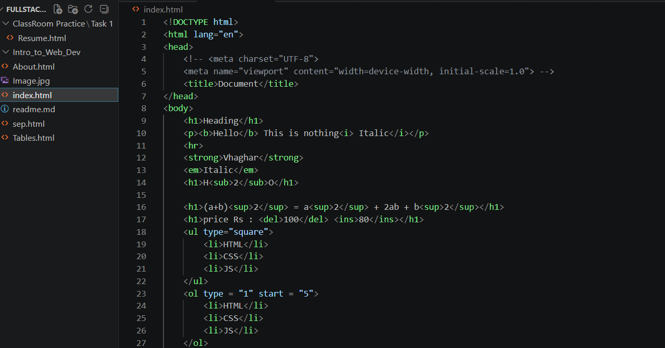
- Explain the difference between static and dynamic websites. Provide an example of each.
Ans:- • Static: Fixed content served as-is to every user (e.g., a simple portfolio website).
• Dynamic: Content updates in real time based on user interactions, database data, or user accounts (e.g., Twitter feed).
- Research and list five web browsers. Explain how rendering engines differ between them.
Ans:- • Google Chrome: Blink engine.
• Apple Safari: WebKit engine.
• Mozilla Firefox: Gecko engine.
• Microsoft Edge: Blink engine.
• Brave: Blink engine.
• Difference: Engines interpret HTML/CSS and execute JS differently, leading to subtle variations in rendering speed, CSS support, and memory optimization across browsers.

- Draw a labeled diagram showing the basic web architecture flow — client, server, database, and APIs.
Ans:- [ Client / Browser ]
│
HTTP │ API Request
▼
[ API / Web Server ]
│
Database │ Queries (SQL/NoSQL)
▼
[( Database )]

